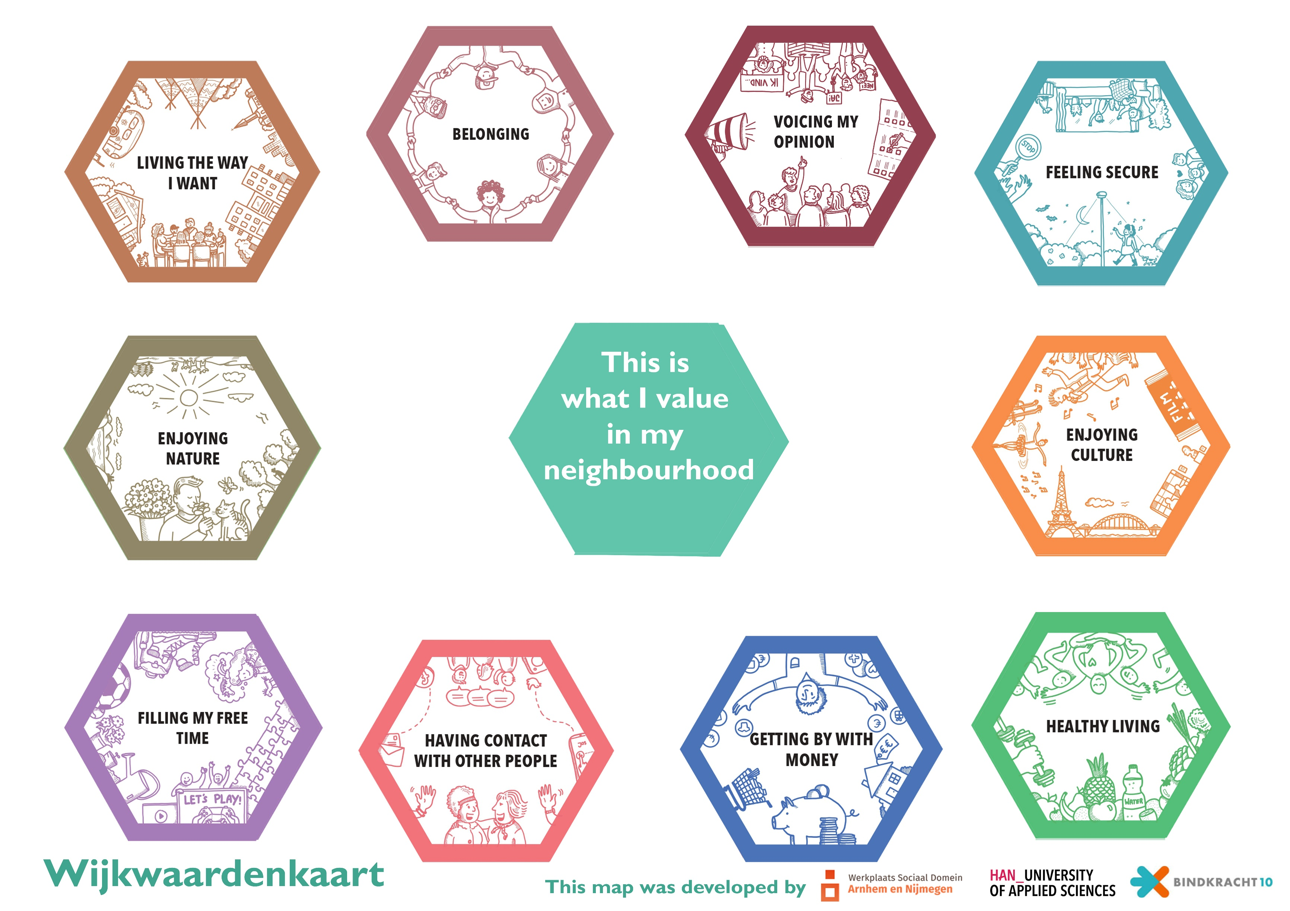
Aandachtlijstje tijdens het gesprek  Houding tijdens gesprek:  - Laat de ander het verhaal vertellen  - Stel open vragen  Volgorde gesprek:  - Introductie en mondelinge toestemming  - Keuze kaarten  - Schaalvragen  - Afsluiting  Introductie  - Het verhaal is belangrijk (you are invited to tell your own story).  - Het gaat om wat de gesprekspartner waardevol vindt (you decide what you would like to tell about the things you value in your neighbourhood).  - Er zijn geen goede of foute antwoorden (there are no wrong or good answers).  Wijkwaarden kaarten  - Stel de vraag: What do you value in your neighbourhood?  - Laat de gesprekspartner 3 kaarten kiezen die het meest waardevol zijn (choose 3 cards which you value most at the moment).  - Nodig de gesprekspartner uit om over de kaarten te vertellen. (Could you explain what is the value of this card?)  - Maak aantekeningen in steekwoorden per kaart.  - Vraag wat helpt of wat lastig is bij de 3 kaarten die gekozen zijn (what is supporting and what is challenging for the cards/topics that you chose?).  - Maak daar ook aantekeningen van in steekwoorden per kaart.  Mogelijke vragen:  - Waarom is dat voor u waardevol? (Why do you value this topic/card?)  - Kunt u een voorbeeld geven? (Could you give an example?) |  | How satisfied you are living in your neighbourhood?    How satisfied you are in having contacts with other people in your neighbourhood?    How satisfied you are with facilities in your neighbourhood?    How satisfied are you with activities in your neighbourhood?  
Plaats hier de link en barcode om het digitaal in te vullen achteraf: |  | Other comments
 |  | General information
 |  | Age |  | Street |  | Household composition
 |  | Duration of residence

